**Assignment 1**

**Question 3**

**Seminar starts now**

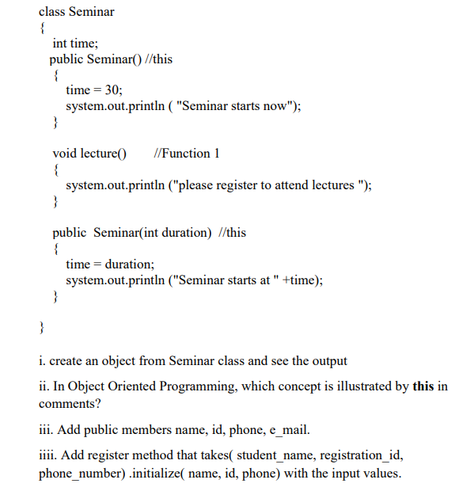

**Constructor Overloading**